Project Proposal

**Body Branding Bookings (3B)**

**A website for managing appointments for tattooists, piercers, body modifiers and their clients.**

Joey Tatú

15015556

joey.tatu@student.ncirl.ie

BSc (Hons) in Computing – Software Development

October 2019

Contents

Annotations 3

1. Objectives 3

General 3

Databases 3

Reviews 3

Appointments 3

Artificial Intelligence 3

2. Background 4

3. Technical Approach 4

4. Special resources required 5

5. Research 5

Personalisation 5

Optimisation 5

6. Project Plan 6

7. Technical Details 6

8. Evaluation 6

References 8

# Annotations

|  |  |
| --- | --- |
| 3B | Body Branding Bookings |
| Artist | Tattooist, piercer or body modifier |
| Client | Customer of the artist |
| User | Artist and/or a client |
| Shop | Tattoo parlour or piercing studio that does tattoos, piercings and/or body modifications |

# Objectives

## General

The object of this Project is to take a brick and mortar scenario[1] of where artists and clients process appointments and payments manually, and create a website where this can be automated.

There will be two main types of accounts on the website; shops and clients. The shop account can either be a solo artist or a collection of artists.

## Databases

There will be two databases connected to the website. These will be encrypted to avoid leaking private information. There will be a Shop database and a Client database.

## Reviews

Reviews of the shops will be generated by the clients. These will be visible on the Shop’s page on the website. The shop can choose to hide a review. Clients must have at least one previous booking with a particular shop to review that shop. This will avoid people never visiting the shop or artist posting reviews.

## Appointments

Shops will generate what days and times the artist(s) are working. The client will book an appointment that is free with the artist. Sample sizes will be provided to generate the correct amount of time to be reserved. A deposit or full payment will be required from the client to confirm their booking.

## Artificial Intelligence

Artificial Intelligence will focus of individualisation as well as the issue of optimisation.

With individualisation, the client will have recommendations. For example, if they generate a piercing appointment, the likes of piercing jewellery or piercing locations would be recommended to them.

With the issue of optimisation, the likes of security and payment handling will be discussed and implemented.

# Background

The original idea for this project came about in early 2019. The thought process was to create a social networking Android app. A website, Inked-Up.com, was a comparison for the app. This site specifically targets adult men who are into body modification such as tattoos and piercings. With this site, it’s felt that it is dealing with a very distinctive niche which would not be ideal for everyone. The site also seems very outdated and seemingly has become a replacement platform from Tumblr, since adult content is no longer permitted. (Tatú, 2018) (Inked-Up.com, 2019)

With new social networking platforms being developed, with an example of TikTok being the newest and most popular, the app was going to be similar to the likes of Facebook and Inked-Up.com, but for everyone with an interest in body modifications. The ability to rate tattoo shops was also to be implemented.

With this current project, it will be on the same general topic; tattoos, piercings and body modifications. Trying to book an appointment to get a tattoo or piercing is quite tedious in some situations. Contacting the artist or shop can be troublesome, either contacting them through social networking sites or by email. There are delays in communication. It seems like a long process just to get an appointment.

It’s common knowledge that, especially, for getting a tattoo, a deposit is required. This means that the client needs to go to the shop or tattooist, give their deposit, and then return for the appointment. If the client doesn’t pay the deposit, their appointment is still there and it wastes the artist’s time. A good starting point to this project is to automate these.

To remedy this, the idea of Body Branding Bookings (3B) was generated. With 3B, the artist can select the dates they wish to work and where they are available. The clients can book one of these timeslots. The general size and/or the time it will take to complete the appointment will be set by the artist and selected by the client to determine the correct time slot needed to be allocated. Artists will have a page where clients can rate and leave reviews.

Java, JavaScript and jQuery will be revisited. These will greatly be beneficial to the project. If a new language is needed, it will be heavily considered.

# Technical Approach

In the next few weeks, the Requirements Specifications will be completed. Taking previous projects into account, it would be a good initiative to have these completed as a basis for the project. After this, the prototype for the Mid-Point Presentation will be worked on. Later at the start of 2020, the project will be developed further. (Tatú, 2018)

To deal with version control, I will be using GitHub and Git Bash. (<https://github.com/JoeyTatu/SoftwareProject>)

For the methodologies, I will be using a mix of Scrum and Kanban, I will be using these methodologies to ensure I understand what needs to be done and to be organised and to keep myself correctly on-track. (Tatú, 2018)

# Special resources required

It is expected that the project will be completed using online tools and services, where possible. I would also like to use the likes of Amazon Web Services or similar. (Tatú, 2018)

# Research

## Personalisation

Brick-and-mortar stores are beginning to put more digital knowhows into their stores. For the clients, this is a great benefit for them by making their experience better. Some of the brick-and-mortar stores are not developing their business’ technological skills, in regard to customer interaction. (Betzing, et al., 2018) However, there are methods of doing this.

When developing from a brick-and-mortar store to a more digitised one, the likes of sensors such as cameras and facial recognition devices can figure out the basics of a person; such as their height, gender, and approximate age. A person’s facial expressions can also be considered to explore whether the client is in a positive or negative mood and whether they are enjoying the service. This data can be obtained by using smart devices on a local network. (Betzing, et al., 2018)

This concept is similar to the physical store Amazon Go by Amazon, where Artificial Intelligence is used to keep track of the clients and store items. (McFarland, 2018)

In this project, it is hoped that a personal experience can be added for the artists and clients. It is expected that personalisation with be sought from a user’s profile, such as their age, gender.

In an example of how this could work; a male client who has just turned 18 and would like to get a tattoo. The system would ask the client to heavily consider whether they would want the tattoo, and to seriously consider avoiding visible areas such as the face, head or hands.

However, if the client is a male in their mid-40s, this message would not be shown to them as the thought process for the client would be different. It could be assumed the client already has a lot of tattoos. Instead, an upload link to share their previously obtained tattoos would be shown. This is developed further in the Requirement Specifications.

## Optimisation

Another consideration of this project is optimisation. If one takes the clothing and textile industry as an example, one can optimise what colours, fabrics and designs are in a high demand. This is completed by eliciting and gathering “Product Usage Information (PUI)”. This is obtained from clients, experts and investors. From this data, the latest styles and what the client wants are known. (Hribernik, et al., 2019)

In this project, optimisation could be used for the general size of the tattoo, the colours of the ink used. If, for example, a lot of tattoos are small and use only use 3 or 4 colours, the system would recognise this and automatically order new colour inks to the artist. On that note, the artist could input how much ink would be used for a particular size and machine learning could be used to order and maintain stock with the artist.

The same would also go for piercings, if a certain ring or stud is used on a regular basis, these could be automatically ordered. The likes of stock control for piercers could also be controlled here. This will be developed with the Requirement Specifications.

# Project Plan

This is the Project Plan. It currently shows all the major milestones and will be updated throughout the Project. (Tatú, 2018)

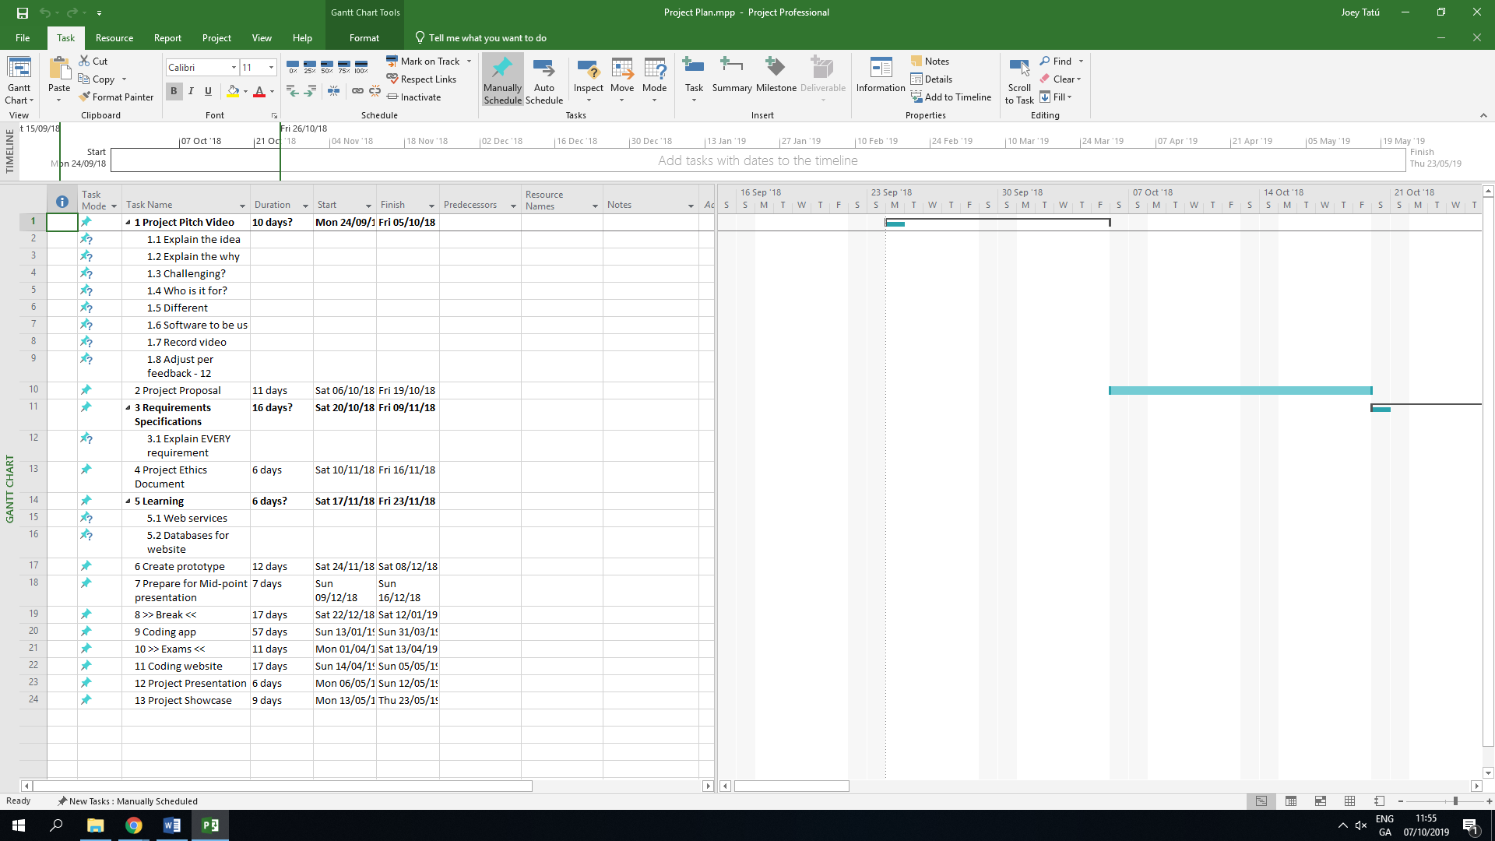

# Technical Details

Web-coding languages such as HTML, CSS, XML, JavaScript (etc) will be used along with SQL (more than likely SQLite). It is expected that Java will be used for the Artificial Intelligence part, but other languages will be considered. (Tatú, 2018)

# Evaluation

Testing of the general features of the site will be completed by myself. A shop and a client account will be created. Checking API calling and connecting to the databases will also be measured. Junit testing will be dealt with to check how the website responds to different scenarios.

# References

Betzing, J. H., Hoang, A.-Q. M. & Becker, J., 2018. *In-store Technologies in the Retail Servicescape,* Münster: University of Muenster.

Hribernik, K., Arabsolgar, D., Canepa, A. & Thoben, K.-D., 2019. Applying Product Usage Information to Optimise the Product Lifecycle in the Clothing and Textiles Industry. In: *Product Lifecycle Management (Volume 4): The Case Studies.* Basel: Spinger, Cham, pp. 73-95.

Inked-Up.com, 2019. *Inked-Up.com.* [Online]   
Available at: http://inked-up.com  
[Accessed 18 October 2019].

McFarland, M., 2018. *I spent 53 minutes in Amazon Go and saw the future of retail.* [Online]   
Available at: https://edition.cnn.com/2018/10/03/tech/amazon-go/index.html  
[Accessed 16 October 2019].

Tatú, J., 2018. *Social Modifications,* Dublin: National College of Ireland.

1. A **brick-and-mortar store** is a traditional store that you find (e.g.) in your local shopping centre.